CECS 491A - Sec 6 - Network Diagram Document

Project Name: ArrowNav

Team Longhorn:

Brayan Fuentes

Christian Lucatero

Curtis Nishihira

Miguel Zavala

Spencer Gravel (Team Leader)

October 27, 2021

1. Design Details
   1. Network Diagram

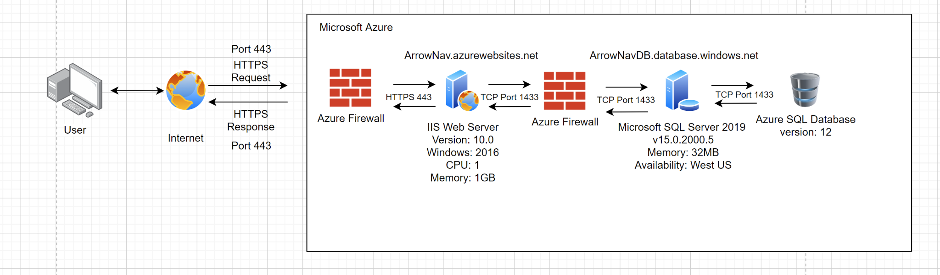

* 1. Hardware Specifications
     1. HTTPS protocols
        1. HTTP protocols are not secure enough so the development team opted to instead use HTTPS. These protocol requests and responses will be routed through the default port of 443.
     2. TCP protocols
        1. Azure utilizes the 1433 port to make tcp requests and response with the sql server with both the web server and the azure sql database
     3. IIS Web Servers
        1. Microsoft Azure’s free app services are limited to 1CPU and 1GB IIS web servers. The server can be configured to windows server version and iis version. The development team chose the most current free option 2016 windows server and IIS v10.0.
     4. Microsoft SQL Server
        1. Microsoft Azure provides web services with the Azure SQL database a fully managed platform running on the most current version of SQL Server and automatically manages database
        2. The free implementation of azure database is a 32mb database limited to one region which the development team selected to be US West and runs on the Microsoft SQL Server 2019 version 15.2000.0.5
     5. Azure SQL Database
        1. The provided azure sql database service will be used as relational database to store information for the web application and is currently running on version 12.
     6. Firewalls
        1. Firewall: Internet to Web Server
        2. Rules:
           1. Azure front door firewall is automatically provided and follows the OWASP core rule set for attack detection
        3. Firewall: Web Server to Database Server
        4. Rules:
           1. Only applications hosted inside Azure will be able to connect to our SQL server. To do so we will be setting a rule with starting and ending IP addresses set to 0.0.0.0

* + 1. Note: Load balancers on the free version of azure are not included
  1. Design Decisions
     1. Implementing a microservice backend which would ideally include multiple databases and web servers to reduce linkages but limitations in funding and time forced the decision to do only one web server and one database server